**LLMs Notes**

**Finetuning**: trainng a pretrained model for a specific task.

Problem: what is there is a very short data or no labled data

Solution: use N-shot learning (transfer learning)

Types of N-shot learning:

1. **Zero-shot**: no task specific data

- No expilict traning

- Uses Languages understaning and context

- Generalize without any prior example

**Example**: Suppose a child has only seen pictures of horses and is asked to identify a zebra with additional information that it looks like a striped horse. In that case, they can correctly identify it without seeing specific examples of zebras

1. **Few-shot**: few task specific data

- Allow model to learn a new task with very few examples

- This is achieved using the knowledge the model has gained from previous tasks

- When the number of examples used for fine-tuning is only one, it is called one-shot learning.

Example: a student attends lectures and takes notes but doesn't study extra for exams. On exam day, they encounter a new question similar to the one taught in the class and can answer it correctly by relying on prior knowledge and experience

1. **Multi-shot**: relatively more traning data

- more exmaples are required for model to learn a new task

- get knowledge from the previous task as well as examples of new task

Exmaple: recognizing different breeds of dogs. If we show the model a few pictures of a Golden Retriever, it can quickly learn to recognize the breed and then generalize this knowledge to similar breeds with just a few more examples

**Pre-training techniques to build LLMs**

Generating Pretraining:

Train using generative pretraining which takes input data of tokens and trained to predict the tokens within the dataset

1. Next word prediction(supervised learning technique)

- Predict next word and generate text

- Capture dependencies between words

- During training, each generated output is added to the input for the next pair, allowing the model to predict the next output.

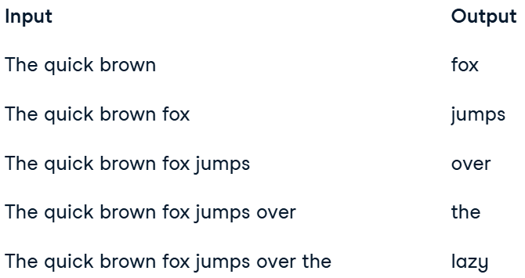

1. Mased language modeling